**Assignment 2 - Move Ball**

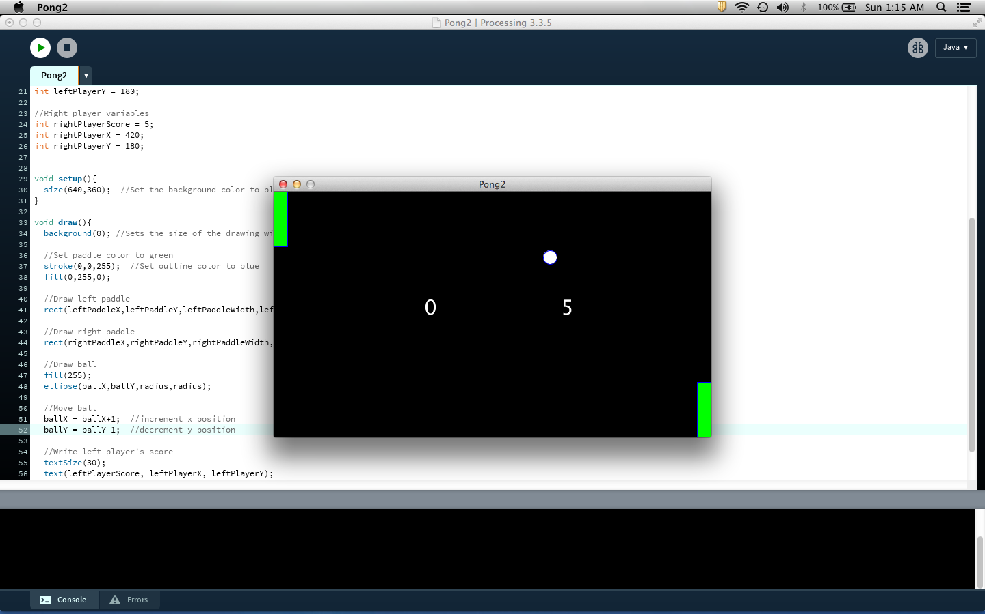

***Note:*** *If you haven’t done so already, go through Lesson: “2.0 Variables” and complete “Quiz 2” first before attempting this assignment*

**Goal**

This assignment requires you to use the knowledge from Lesson 2 about variables to make the ball of the Pong game move.

**Instructions**

**Code Setup**

Do the following steps carefully. **Note that failure to do so would result in getting a grade of zero for this assignment because AutoGrad won’t be able to grade your work!**

1. Open the program Assignment2, and rename both 1) the program and 2) the tab by adding “**_”** andyour student id at the end like “Assignment2_sa321” as shown in “Course Apps Setup” page 12 and 13. You can get your student id by going to [this link](http://suacode.netlify.app), entering the course id (sa002), and the email you used to sign up for Piazza.
2. Copy your code from Assignment1 and paste it into Assignment2
3. Put your ***maxX*** and ***maxY*** values in the comment at the top of the code by replacing the *** with your values.
4. Make sure the ***fullScreen()*** function is within your ***setup()*** function.

**Assignment Specifications (specs)**

Write a program that makes the ball of your Pong game move with the following instructions:

1. Modify the program to use variables to store the following and make sure they are all integers
   1. Ball’s *x* and *y* positions, width, height.
   2. Left paddle *x* and *y* positions,
   3. Right paddle *x* and *y* positions
   4. Paddle width and paddle height (remember that the left and right paddles should both have the same width and height)
   5. Left player score, *x,* and *y* positions.
   6. Right player score, *x,* and *y* positions.
   7. Text size
2. Choose variable names that are descriptive and to use remember the camelCase naming style
3. Make ball move at a certain speed and direction
   1. Use variables for the ball’s *x* speed and *y* speed
   2. Don’t use the shorthand method for incrementing and decrementing variables
4. Make sure you have no magic numbers in your code except for the parameters of your coloring functions
5. Add comments to your code
6. Your code looks cleaner when you group lines of code together like grouping all code of the ball together, and then the code for the paddles together, then code for the scores together, etc.
7. Make sure to indent your code properly
8. Take a screenshot of your program’s output after running i.e, the ball moving

**Extra Credit (Optional)**

If you are feeling ambitious, you can try this extra credit work and submit it as an extra credit work. Note that we will not grade this but we will randomly go through them and highlight the ones that are nice. Make sure you have completed the main assignment instructions before attempting this.

* Create a new Sketch with the name Assignment2_sa123.pde
  + You have to move the new Sketch to your Sketchbook before you can rename it
* Go to Sketch Properties -> Locked Orientation and select Landscape
* Copy your Assignment2 code into this Sketch
* Some ideas you can try using knowledge from only lessons 1 and 2
  + Have a line passing through the center but ball covers the center
  + Add text “Player 1” before the left score and “Player 2” before right score
  + Add an additional ball of different color and make it move in a direction a different from the other ball
  + Make your program output look the same irrespective of the phone screen size (maxX and maxY) on which it runs (you can do that by defining your variables with reference to the built-in variables *width and height* like in Ex. 2.2)
  + Other cool ideas you may have (again only using knowledge from lesson 1 and 2)

**Submission**

1. Before submitting your code, make sure your code runs without any errors. Also, make sure you have done everything outlined in the instructions exactly.
2. Submit your assignment at this submission link which will only be available 48 hours before the assignment deadline: [**link here**](https://bit.ly/ass2-form)
   * **NB:** You should still start working on the assignment early as we are using this measure to prevent people from making wrong submissions because they are rushing